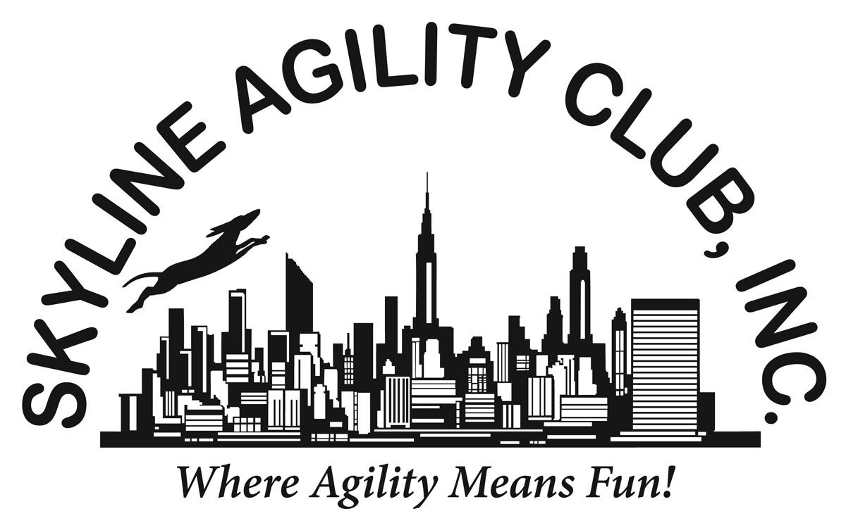
Skyline Agility Club, Inc. Presents Agility Workshops with John Nys
120 Tetz Road, Middletown, NY 10923
For info and to register: Karenpro@aol.com (Karen Profenna)

John Nys has been competing on the Local, National and International dog agility stage for over 15 years. During this time he has become one of the most respected competitors and instructors in agility. He is well known for his positive motivation and mental management/coaching with his students and canine companions. John and Rush are one of the most decorated world team agility team members with 5 Silver Medals and 1 Gold Medal in the individual agility, jumping and team events.
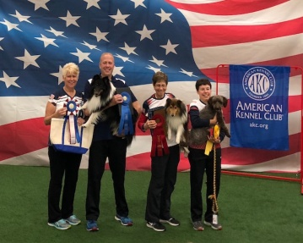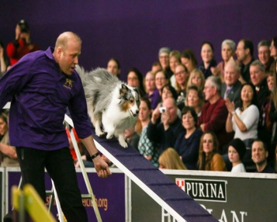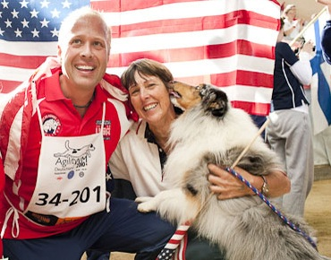
PROGRAM: Wraps and Collection (1 spot open)
DATE: Saturday, September 26, 2020
TIME: 8:00 a.m.-12 p.m.
Working Spots: 8 teams (members $120/nonmembers $140)
Auditing Spots: Unlimited (members $20/nonmembers $25)

PROGRAM: Mastering Efficient Course Handling
DATE: Saturday, September 26, 2020
TIME: 1:00 p.m.-5:00 p.m.
Working Spots: 8 teams (members $120/nonmembers $140)
Auditing Spots Unlimited (members $20/nonmembers $25.00

PROGRAM: Foundations Skills (For foundation the dogs should be at least 8 months or older. Basic equipment familiarization. No contacts unless requested. This will consist of training efficient turns and wraps. )
DATE: Sunday, September 27, 2020
TIME: 8:00 a.m.-12:00 p.m.
WORKING SPOTS: 8 teams (members $120/nonmembers $140)
AUDITING SPOTS: Unlimited (members $20/nonmembers $25)

PROGRAM: Distance Work
DATE: Sunday, September 27, 2020
TIME: 1:00 p.m.-5:00 p.m.
WORKING SPOTS: 8 teams (members $120/nonmembers $140)
AUDITING SPOTS: Unlimited (members $20/nonmembers $25)

